50. International Seminar of Scientific Clubs in Olsztyn
"Seminar of imaging student's scientific thought"
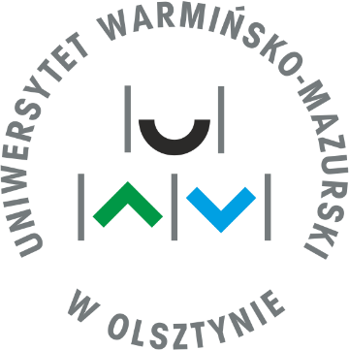
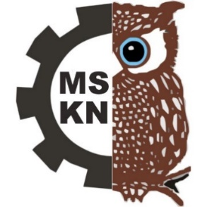
16-17th September 2021

Students’ Scientific Club of Imaging Techniques in Small Animals Diagnostic, operating in the Department of Veterinary Medicine at the University of Warmia and Mazury in Olsztyn and Students’ Scientific Club of Political Regimes CASUS from Department of Law and Administration UWM are happy to invite you to take part in 50. Edition of International Seminar of Scientific Circles in Olsztyn "Seminar of imaging student's scientific thought". The Event will be held on September 16-17th, 2021.
This year’s edition is special, because it is the jubilee 50th Seminar. For this occasion we organised a lot of attractions and suprises. We invite you to meet with us.
This year’s topics will include:
- Biological sciences
- Economic sciences
- Humanities
- Mathematics and computer science
- Medical science
- Political and legal sciences
- Agricultural, forestry and environmental sciences
- Social and pedagogical sciences
- Technical sciences
- Theological sciences
- Veterinary science
- Animal science and fishery
- Health science
- Food science

Registration – via the form – from 05.03.2021 to 02.04.2021
Form is available on the Website: http://www.uwm.edu.pl/mskn/
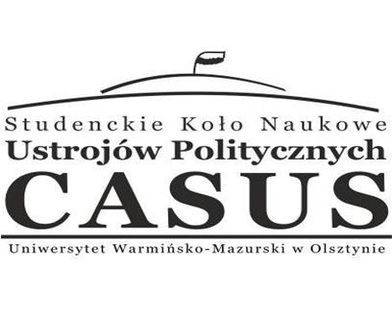
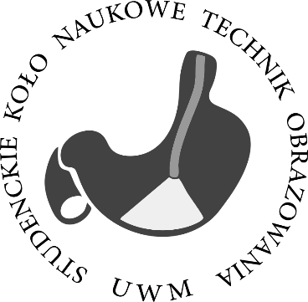
For more information:
http://www.uwm.edu.pl/mskn/
http://www.facebook.com/mskn.olsztyn
Contact:
50mskn2021@gmail.com

We invite you to take part with us!

