RIS SUMMER SCHOOL
in TARGETED NUTRITION
3rd September – 1st October 2021
ONLINE
Would you like to become one of the innovation leaders of the future gastronomy sector?
Join the group of creative young people, who supported by researchers, industry experts, and professional chefs will co-create new concepts and products addressing the needs of allergic and hypersensitive consumers. In our school, you will get state-of-the-art knowledge and skills around management of food safety hazards and the development of targeted nutrition solutions. You can rebuild the trust of consumers in food services, just believe that food hypersensitivity is not only a challenge but also an opportunity!
Apply now to RIS Summer School in Targeted Nutrition powered by EIT Food!
APPLY at: bit.ly/3wPJea8
MORE INFORMATION: www.pan.olsztyn.pl
The EIT Food RIS Summer School in Targeted Nutrition is organized by Institute of Animal Reproduction and Food Research PAS (Poland) together with Arhus University (Denmark), Matis (Iceland), IMDEA Food (Spain), Bologna University (Italy), BCC Innovation Culinary Center (Spain) and University of Cambridge (England).
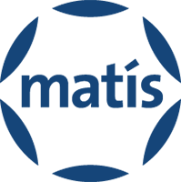
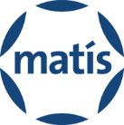

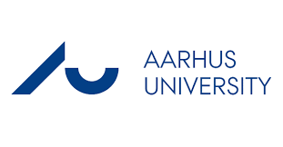

OVERVIEW
The RIS Summer School will be available fully online from September 3rd until October 1st, 2021. Most of the time, students will work flexibly at the times of their convenience. They will also participate in live-hosted online exercises. Learning will include lectures on the state-of-the-art knowledge on food allergy, entrepreneurship modules, quizzes, message boards and problem-solving exercises.
The program has 4 main phases: introductory phase, early phase, middle phase and final phase.
- Introductory phase (September 3rd) students will define their competence profiles to facilitate further division into subgroups
- Start-up phase (September 6th-10th) includes entrepreneurship modules and a number of lectures on the different aspects of food allergy and allergens delivered as asynchronous blocks. In addition, quizzes dedicated to food allergens will be included as well as some live online activities. A detailed timetable will be available on the Canvas platform.
- Middle phase (September 13th-17th): the content of this phase is mainly focused on entrepreneurship. During this week students will have an online discussion dedicated to ideating and prototyping, intellectual property rights , trademarks and copyright. One of the live online activities will be performed to provide students with information and instructions on effective pitching and communication. Additionally, students will have the opportunity to hear the success story of Rising Food Stars.
- End phase (27th September-1st October): last week of the Summer School contains three blocks of the entrepreneurship and two food-related lectures on nutritional programming and microbiological aspects of food allergy. Students will participate online in a live culinary adventure with professional chefs. October 1st is the date of the Final Pitch in front of a professional jury, followed by teams graduation and winners awarding.
EVERYTHING YOU NEED TO KNOW
Who can apply:
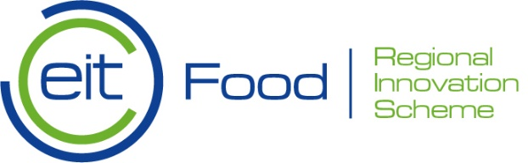
The course is open to Bachelor, MSc and PhD students as well as graduates and professionals interested in nutrition and food. The course would also suit aspiring entrepreneurs or professionals wishing to move into this sector. There is no precondition concerning your study background.

Territory requirements:
Applications are accepted from the following territories (based on citizenship):
Albania, Armenia, Bosnia and Herzegovina, Bulgaria, Croatia, Cyprus, Czech Republic, Estonia, Faroe Islands, Georgia, Greece, Hungary, Italy, Latvia, Lithuania, Malta, Moldova, Montenegro, North Macedonia, Poland, Portugal, Romania, Serbia, Slovakia, Slovenia, Spain, Turkey, Ukraine.
Language requirements:
English
CAREER OPPORTUNITIES
RIS Summer School in Targeted Nutrition aims to educate young academics and ignite their entrepreneurial talents. The School will mentor a new generation of European food innovators, through an entrepreneurial approach linked to food allergies. Students will be provided with state-of-the-art knowledge and skills around the management of food safety hazards and the development of targeted nutrition solutions.

